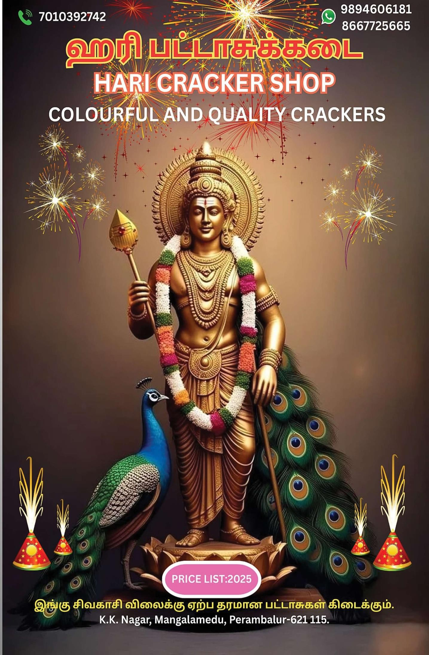

Price List 2026



S.No | Product Name | Rate | Per | QTY | Amount
ONE SOUND CRACKERS
1 | 2 3/4 KURUVI | ₹15 | 1 Pkt |  | ₹10
2 | LAKSHMI 4" [INCH] | ₹25 | 1 Pkt |  | ₹20
3 | GOLD LAKSHMI [12 PLY] | ₹55 | 1 Pkt |  | ₹40
4 | 5" BAHUBALI / LAKSHMI | ₹70 | 1 Pkt |  | ₹60
5 | 5" UNICORN DLX [20 PLY] | ₹90 | 1 Pkt |  | ₹70
6 | 6" WARRIOR | ₹95 | 1 Pkt |  | ₹80
7 | 2 SOUND | ₹60 | 1 Pkt |  | ₹40
FLOWER POTS (PANDIYAN, JOKER, NEW EVEREST)
8 | FLOWERPOTS BIG | ₹100 | 1 Box |  | ₹80
9 | FLOWERPOTS SPECIAL | ₹120 | 1 Box |  | ₹100
10 | FLOWERPOTS ASHOKA | ₹155 | 1 Box |  | ₹140
11 | FLOWER POTS PURPLE COLOUR KOTTI (SONNY) | ₹800 | 1 Box |  | ₹650
12 | COLOUR KOTTI | ₹280 | 1 Box |  | ₹200
13 | COLOUR KOTTI DLX [10PCS] | ₹370 | 1 Box |  | ₹350
14 | TRI COLOUR FOUNTAIN | ₹260 | 1 Box |  | ₹260
15 | COLOR KOTTI (REG & GREEN) | ₹450 | 1 Box |  | ₹250
16 | SUPER MEGA DLX [SONNY] | ₹750 | 1 Box |  | ₹700
17 | COLOUR PINJORE | ₹250 | 1 Box |  | ₹240
18 | GYPSY [SURIYA KALA] | ₹190 | 1 Box |  | ₹180
GROUND CHAKKAR (PANDIYAN, JOKER, JENIS)
19 | GROUND CHAKKAR BIG | ₹60 | 1 Box |  | ₹50
20 | GROUND CHAKKAR SPECIAL | ₹100 | 1 Box |  | ₹90
21 | GROUND CHAKKAR DLX | ₹165 | 1 Box |  | ₹155
22 | GROUND CHAKKAR ASHOKA | ₹120 | 1 Box |  | ₹100
23 | GROUND CHAKKAR PLASTIC SPECIAL | ₹155 | 1 Box |  | ₹140
24 | GROUND CHAKKAR PLASTIC DLX | ₹200 | 1 Box |  | ₹200
25 | GROUND CHAKKAR SUPER DLX | ₹300 | 1 Box |  | ₹200
BIJILI & WALA
26 | BIJILI 100 | ₹60 | 1 Pkt |  | ₹50
27 | 24 DELUX | ₹50 | 1 Pkt |  | ₹50
28 | 50 DELUX | ₹100 | 1 Pkt |  | ₹100
29 | 100 DELUX [SPL] | ₹230 | 1 Pkt |  | ₹200
30 | 1000 WALA | ₹250 | 1 Box |  | ₹200
31 | 2000 WALA | ₹550 | 1 Box |  | ₹400
32 | 5000 WALA | ₹1,250 | 1 Box |  | ₹1,000
33 | 10000 WALA | ₹2,500 | 1 Box |  | ₹2,000
ATOM BOMB'S
34 | CLASSIC BOMB | ₹140 | 1 Box |  | ₹130

S.No | Product Name | Rate | Per | QTY | Amount
35 | PAPER BOMB 1/4 KG | ₹70 | 1 Box |  | ₹55
36 | PAPER BOMB 1/2 KG | ₹130 | 1 Box |  | ₹110
37 | PAPER BOMB 1 KG | ₹260 | 1 Box |  | ₹220
TWINKLING STAR
38 | 4 1/2 TWINKLING STAR | ₹80 | 1 Box |  | ₹60
MATCH BOX COMB
39 | ELECTRIC STONE | ₹25 | 1 Box |  | ₹20
40 | KITKAT | ₹50 | 1 Box |  | ₹35
41 | SUPER DLX 10 IN1 | ₹20 | 1 Box |  | ₹10
42 | CLASSIC 5 IN1 | ₹45 | 1 Box |  | ₹40
CHILDREN'S SPECIAL
43 | DANCING PEACOCK SPECIAL | ₹800 | 1 Box |  | ₹200
44 | BADA PEACOCK | ₹450 | 1 Box |  | ₹450
45 | BADA PEACOCK [8 COLOUR CHANGING] AND PINK COLOUR | ₹750 | 1 Box |  | ₹600
46 | PEACOCK FEATHER | ₹110 | 1 Box |  | ₹100
47 | BUTTERFLY | ₹120 | 1 Box |  | ₹100
48 | RAMPA DANCE PAMBARAM | ₹150 | 1 Box |  | ₹100
49 | HELICOPTER | ₹155 | 1 Box |  | ₹100
50 | SIREN (2PCS) | ₹180 | 1 Box |  | ₹180
51 | COLOUR RAINS | ₹115 | 1 Box |  | ₹100
52 | 4X4 | ₹200 | 1 Box |  | ₹180
53 | MURUGAN VEL WATERFALL | ₹250 | 1 Box |  | ₹200
PENCIL SPECIAL
54 | NAVARANGA [SRI VIJAY] | ₹280 | 1 Box |  | ₹180
55 | KASHMIR COOL PENCIL | ₹250 | 1 Box |  | ₹200
56 | MALABAR PENCIL | ₹220 | 1 Box |  | ₹200
57 | COLOUR SMOKE (TRI COLOUR) | ₹250 | 1 Box |  | ₹150
58 | LALA CANDY | ₹380 | 1 Box |  | ₹180
59 | COLOUR CANDY | ₹220 | 1 Box |  | ₹180
NEW SPECIAL FOUNTAINS [RAVIKANNAN, MOTHERS, VADIVEL]
60 | TOUCH AND TOUCH | ₹110 | 1 Box |  | ₹100
61 | GOLDEN BAR | ₹105 | 1 Box |  | ₹100
62 | 6000 FANCY | ₹175 | 1 Box |  | ₹170
63 | POPPING FANCY | ₹180 | 1 Box |  | ₹170
64 | TWEET FANCY | ₹200 | 1 Box |  | ₹170
65 | KING OF KING [5G] | ₹220 | 1 Box |  | ₹160
66 | MINI TRI COLOUR | ₹250 | 1 Box |  | ₹150
67 | BLACK & WHITE | ₹150 | 1 Box |  | ₹100
67 | LUCKY [MOTHER] | ₹280 | 1 Box |  | ₹230
69 | RANGOLA QUEEN | ₹300 | 1 Box |  | ₹200
70 | POGO JOLLY RANGER [5PCS] | ₹200 | 1 Box |  | ₹170
NEW WONDERS
71 | SHIN CHAN | ₹200 | 1 Box |  | ₹170
72 | WONDER 3 | ₹300 | 1 Box |  | ₹270
73 | POWER RANGER | ₹250 | 1 Box |  | ₹220

S.No | Product Name | Rate | Per | QTY | Amount
74 | RED BLOOM MIX | ₹280 | 1 Box |  | ₹230
75 | RAINY & SHINY | ₹260 | 1 Box |  | ₹250
76 | MICKY MOUSE | ₹500 | 1 Box |  | ₹400
77 | ELEPHANT WONDER | ₹450 | 1 Box |  | ₹300
78 | LION WONDER | ₹450 | 1 Box |  | ₹300
79 | STAR SHOW | ₹250 | 1 Box |  | ₹150
80 | MUSICAL POTS | ₹500 | 1 Box |  | ₹200
RAJKALA WOW STAR
81 | GEM MIX COLOUR | ₹220 | 1 Box |  | ₹200
82 | LAYZ | ₹190 | 1 Box |  | ₹160
83 | KUR KUR | ₹200 | 1 Box |  | ₹180
RAINBOW POP FANCY [VADIVEL, PANDIYAN, ORIENT]
84 | NESTLE [5PCS] | ₹300 | 1 Box |  | ₹240
85 | STAR DRUM | ₹160 | 1 Box |  | ₹130
86 | LEMON TREE | ₹250 | 1 Box |  | ₹150
87 | WHISTLING DLXIE [5PCS] | ₹200 | 1 Box |  | ₹100
88 | SOEI MAAR | ₹350 | 1 Box |  | ₹270
89 | MINI KULFI | ₹200 | 1 Box |  | ₹100
90 | ICE KULFI SPL | ₹200 | 1 Box |  | ₹140
91 | PINK FOREST ORIENT | ₹400 | 1 Box |  | ₹200
92 | GEMS MIXTURE | ₹280 | 1 Box |  | ₹200
93 | CYLINDER 666 | ₹220 | 1 Box |  | ₹180
94 | MUSICAL ROCKET | ₹180 | 1 Box |  | ₹130
VOLCANO BLAST [PANDIYAN, RAJKALA, SURYAKALA]
95 | 1" CHOTTA FANCH | ₹100 | 1 Box |  | ₹50
96 | PENTA SHOT | - | 1 Box |  | ₹180
97 | 3 1/2 PIPE | ₹500 | 1 Box |  | ₹300
98 | 4" INCH | ₹700 | 1 Box |  | ₹400
99 | DIGITAL STAR | ₹800 | 1 Box |  | ₹400
100 | NAYAGARA FALLS | ₹550 | 1 Box |  | ₹400
101 | DOUBLE BALL | ₹700 | 1 Box |  | ₹600
102 | 5" INCH | ₹660 | 1 Box |  | ₹600
103 | 12 STEP | ₹500 | 1 Box |  | ₹400
104 | 7 STEP | ₹800 | 1 Box |  | ₹400
MULTI COLOUR SHOT [RAVIKANNAN, RHINO, LIYA]
105 | 7 SHOT [GOLDEN TREE SONNY] | ₹250 | 1 Box |  | ₹250
106 | 12 SHOT | ₹130 | 1 Box |  | ₹130
107 | 25 [RIDER] | ₹250 | 1 Box |  | ₹250
108 | 30 SHOT | ₹450 | 1 Box |  | ₹450
109 | 30 SHOT [BRANDED] | ₹500 | 1 Box |  | ₹500
110 | 60 SHOT | ₹900 | 1 Box |  | ₹900
111 | 60 SHOT [BRANDED] | ₹1,000 | 1 Box |  | ₹1,000
112 | 120 SHOT | ₹1,800 | 1 Box |  | ₹1,800
113 | 120 SHOT [BRANDED] | ₹2,000 | 1 Box |  | ₹2,000
114 | 240 SHOT | ₹3,600 | 1 Box |  | ₹3,600

S.No | Product Name | Rate | Per | QTY | Amount
115 | 240 SHOT [BRANDED] | ₹3,800 | 1 Box |  | ₹3,800
2026 NEW ELITE FANCY
116 | WOW PURPLE | ₹680 | 1 Box |  | ₹600
117 | WOW PINK | ₹800 | 1 Box |  | ₹600
118 | WOW LEMON | ₹1,600 | 1 Box |  | ₹600
119 | 30 SHOT [PEACOCK DANCING] | ₹1,400 | 1 Box |  | ₹500
120 | 30 SHOT [CRACK SOCK] | ₹1,500 | 1 Box |  | ₹600
MONSTER BEAST COMB [RAJKALA, LIYA, SONNY]
121 | 2" [2 PCS] | ₹1,500 | 1 Box |  | ₹250
122 | 3" [3 PCS] HIP HOP SERIES | ₹780 | 1 Box |  | ₹600
123 | 4" INCH [2 IN 1 FANCY] | ₹450 | 1 Box |  | ₹400
124 | 4" INCH [2 IN 1] VIOLET COLOUR | ₹3,500 | 1 Box |  | ₹2,000
CARNIVAL DISPLAY SETOUT [SONNY, LIYA, PANDIYAN]
125 | OSCAR BUTTERY [SONNY] | ₹5,000 | 1 Box |  | ₹2,000
126 | 10X10 IPL SHOW [LIYA] | ₹6,000 | 1 Box |  | ₹4,000
127 | 30 SHOT [UNIVERSAL PIPE] | ₹5,500 | 1 Box |  | ₹4,000
128 | BHARATRATHAN (2" 1/2) | ₹2,800 | 1 Box |  | ₹1,600
129 | HOT GIRL | ₹2,000 | 1 Box |  | ₹1,700
130 | MASS DISPLAY [4X5] | ₹3,300 | 1 Box |  | ₹1,400
131 | SIZZLING (LIYA) 5X5 | ₹3,000 | 1 Box |  | ₹2,500
SPARKLERS
132 | 10CM SPARKLERS | ₹30 | 1 Box |  | ₹20
133 | 10CM GREEN | ₹45 | 1 Box |  | ₹25
134 | 10CM RED | ₹55 | 1 Box |  | ₹25
135 | 15CM SPARKLERS | ₹60 | 1 Box |  | ₹50
136 | 15CM GREEN | ₹75 | 1 Box |  | ₹55
137 | 15CM RED | ₹60 | 1 Box |  | ₹55
138 | 30CM SPARKLERS | ₹80 | 1 Box |  | ₹50
139 | 30CM GREEN | ₹100 | 1 Box |  | ₹55
140 | 30CM RED | ₹100 | 1 Box |  | ₹55
141 | 50CM SPARKLERS | ₹350 | 1 Box |  | ₹200
142 | SPINNING SPARKLERS | ₹400 | 1 Box |  | ₹220

